**S.E-1002L**

**Object Oriented Programming Lab**

**<<OOP BANK>>**

**Project Report By**

**<<Ali Sarwar>>**

**Group Members:**

<<Ali Sarwar>> <<SE201039>>

<<Muhammad Hamza Khalid>> << SE201028>>

<<Syed Tariq Hasan Shah>> << SE201050>>

Table of Contents

1. Introduction 3

2. Scope 3

3. Class Diagrams 3

4. Module Description 3

5. Hardware/Software Requirements 3

5.1 Tools 3

5.2 Libraries , IDE 3

6. Screen Shots 3

7. Task Sheet 3

# Introduction

OOP Bank allows customers to conduct online transactions on a secured system. Our project is based on OOP Bank system in Java. This project is based on customer account services in bank. This system allows user to signup account and other some activities like real bank.

# Scope

# The purpose of this project is in partial fulfilment of the requirements of customer using the online banking for payment or transactions. The Design and development of this OOP Bank system provides a more secured approach in managing bank customer’s information which strengthens the relationships between banks and their customers by providing the right solutions that uses a multi-level security to improve customer satisfaction.

# Class Diagrams

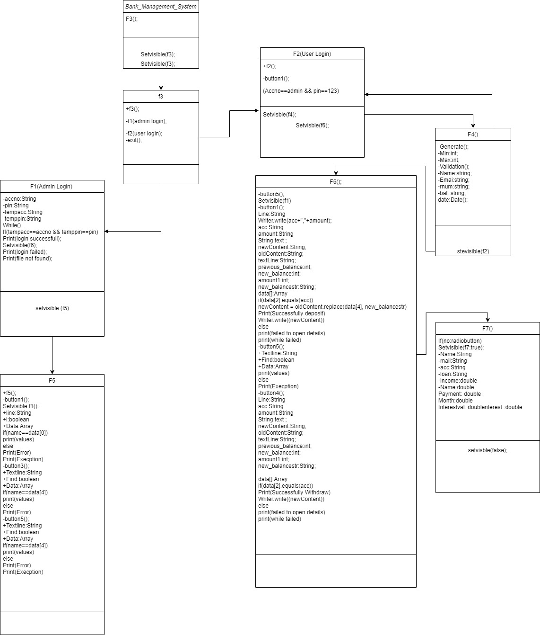

# Module Description

* The whole process of banking is showed in the code like creating new account, displaying details, deposits, withdraw. This project is based on customer account services in bank.
* This system allows user to signup account.
* The user can enter account details to perform transactions.
* Check the details of a current account, bank balance & credit card.
* Admin has the access of all the accounts (as an owner). From which he can watch the user activity.
* Account holder can apply for loans

# Hardware/Software Requirements

# Hardware :

* i3 2.2 GHZ processor or equivalent
* 2 gb ram
* 100 mb disk space
* Windows xp,7,8 & 10

**Software Requirements:**

## 5.1 Tools

* Net Beans
* Eclipse
* IntelliJ

## 5.2 Libraries

java.awt.Dimension;

java.awt.Toolkit;

java.io.FileWriter;

javax.swing.JOptionPane;

java.awt.Toolkit;

java.io.BufferedReader;

java.io.File;

java.io.FileNotFoundException;

java.io.FileReader;

java.io.FileWriter;

java.io.IOException;

java.util.logging.Level;

java.util.logging.Logger;

java.util.Scanner;

java.awt.TextArea;

java.awt.Toolkit;

java.text.SimpleDateFormat;

java.util.Date;

javax.swing.JtextField;

java.awt.Toolkit;

javax.swing.Jframe;

# 6. Screen Shots

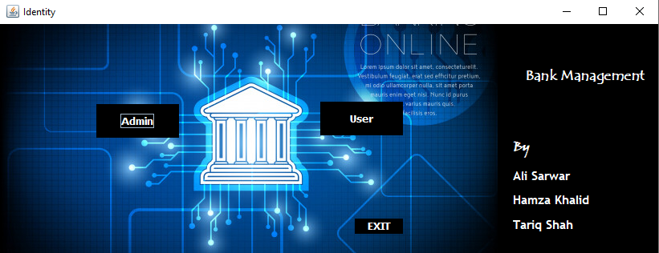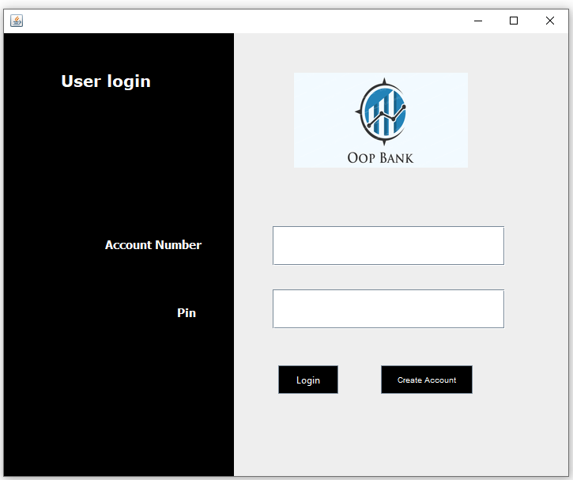

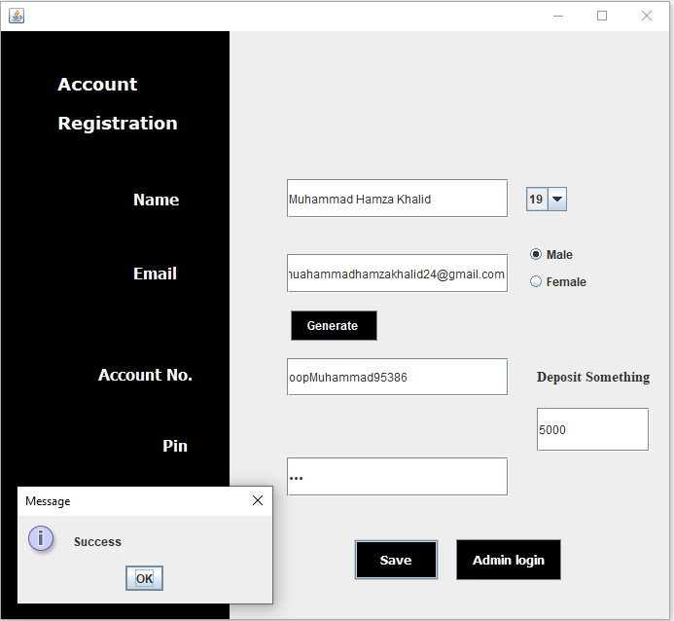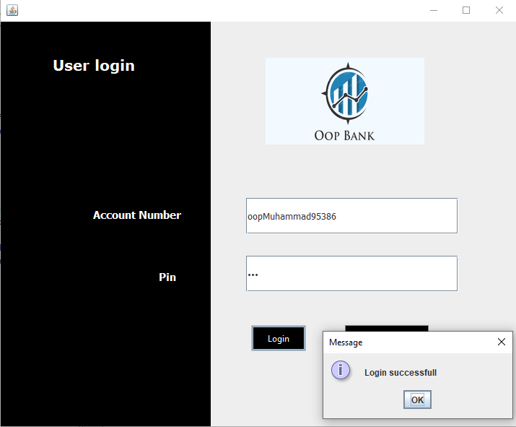 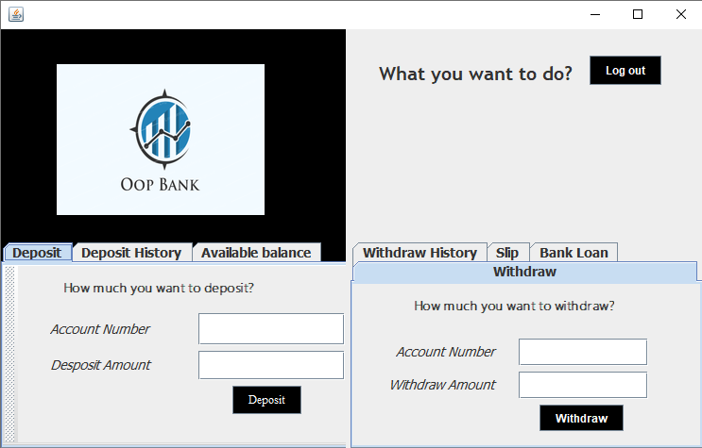

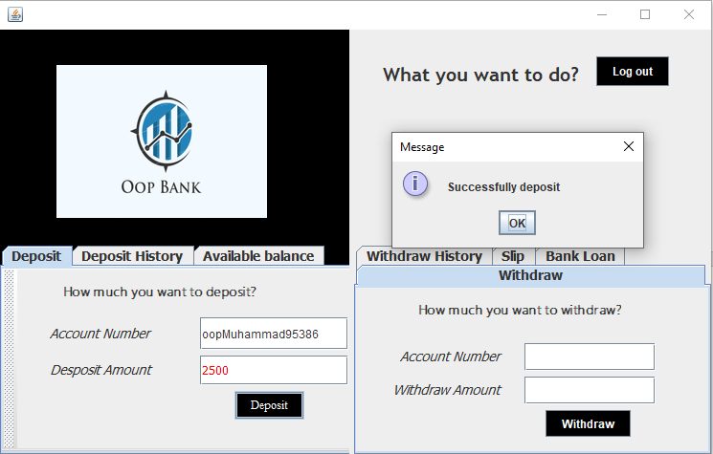

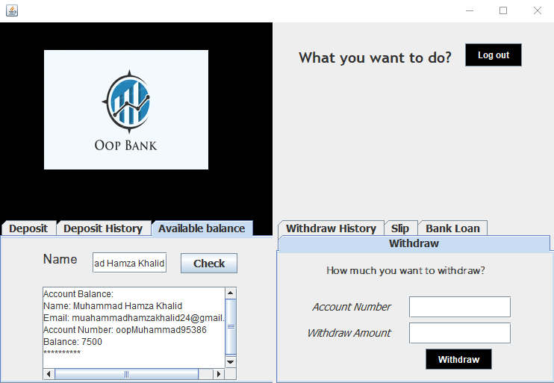

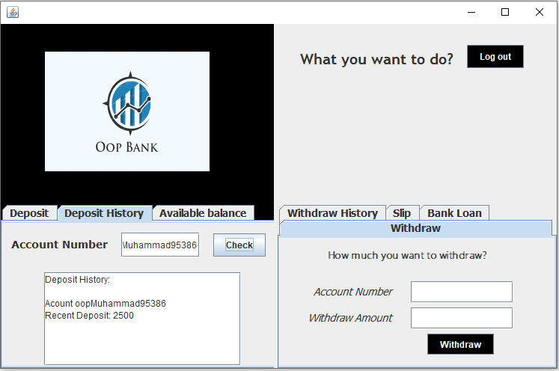

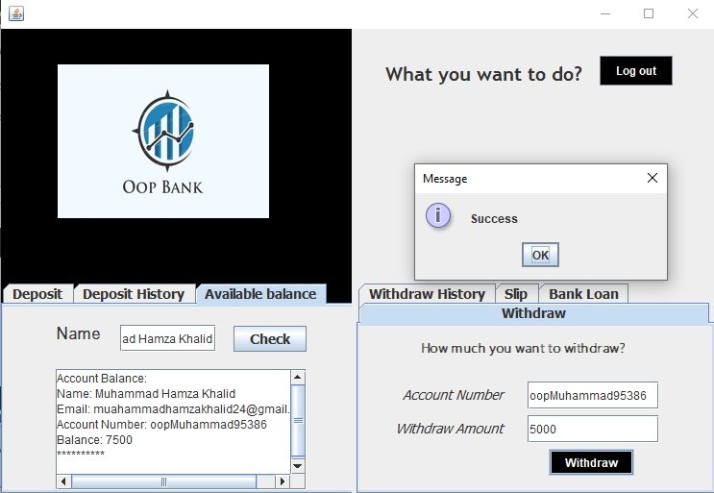

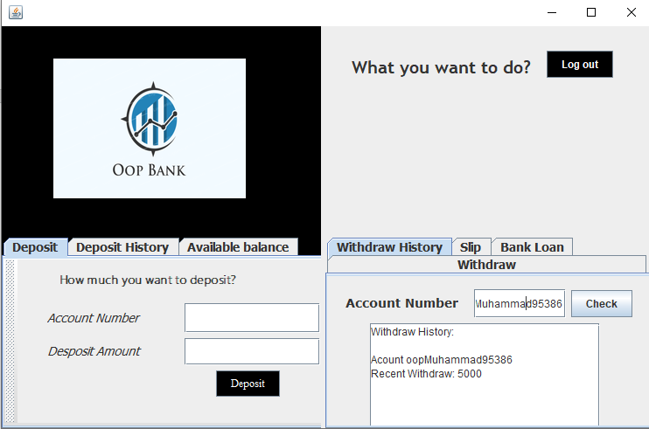

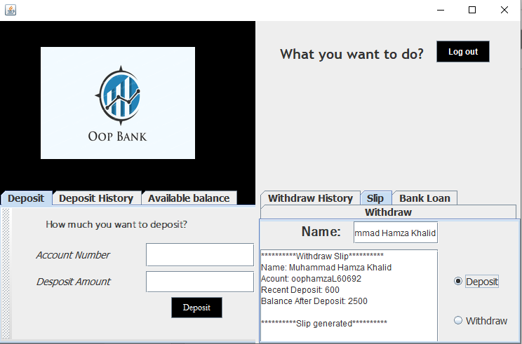

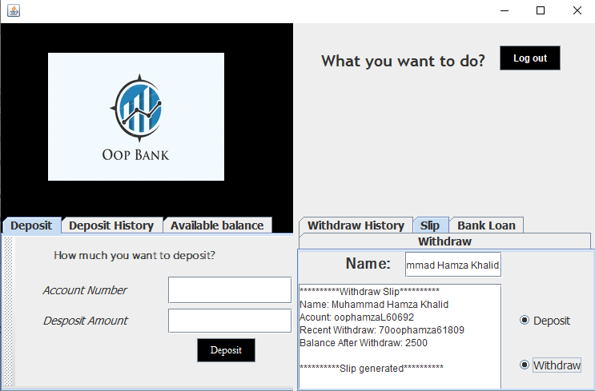 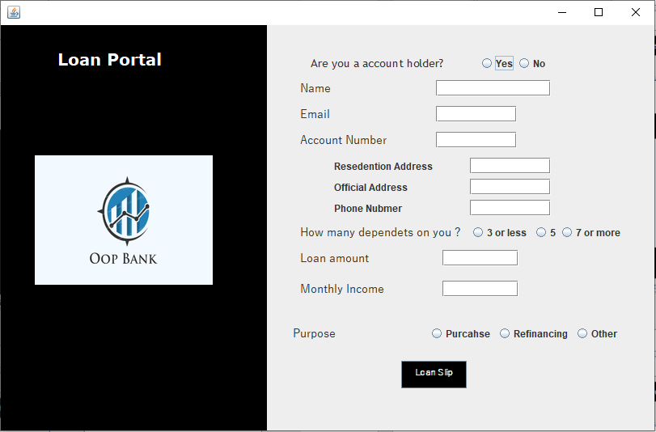

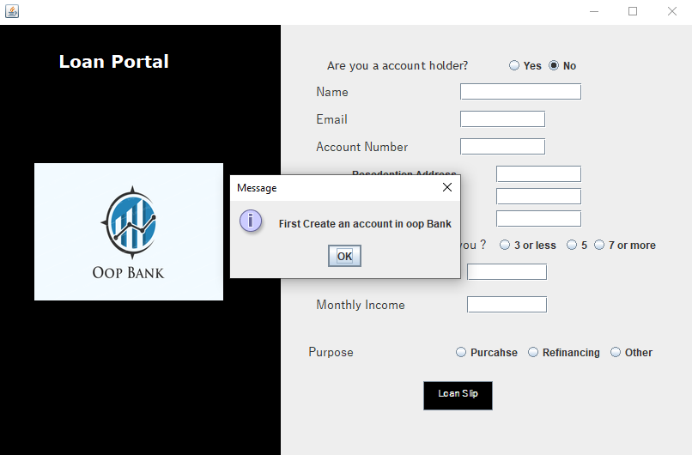

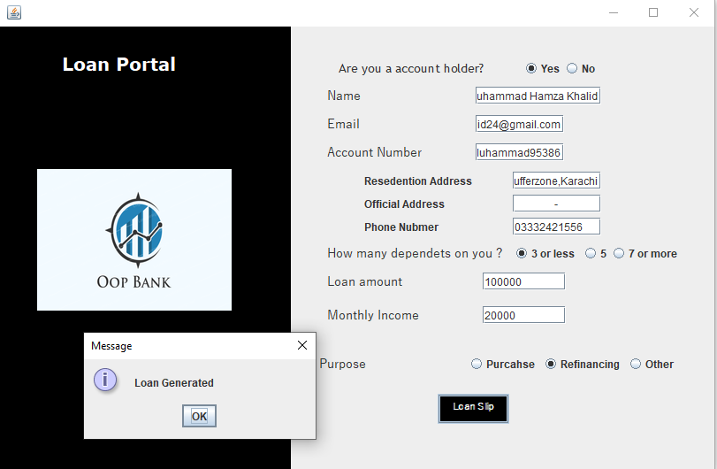 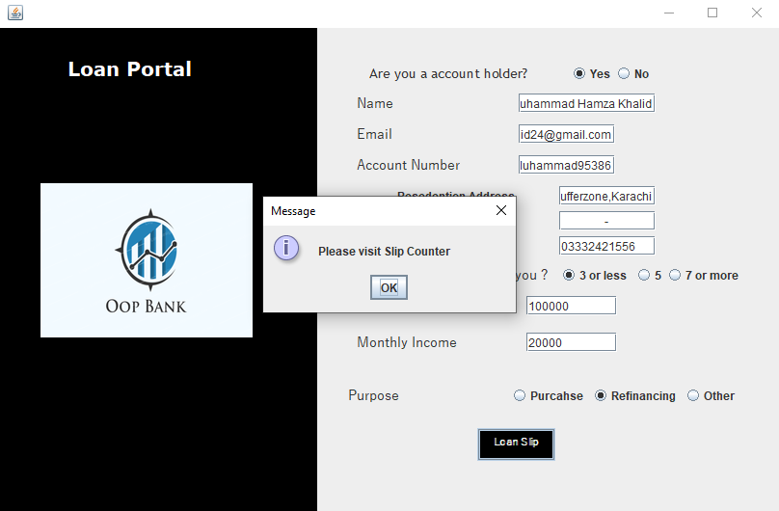 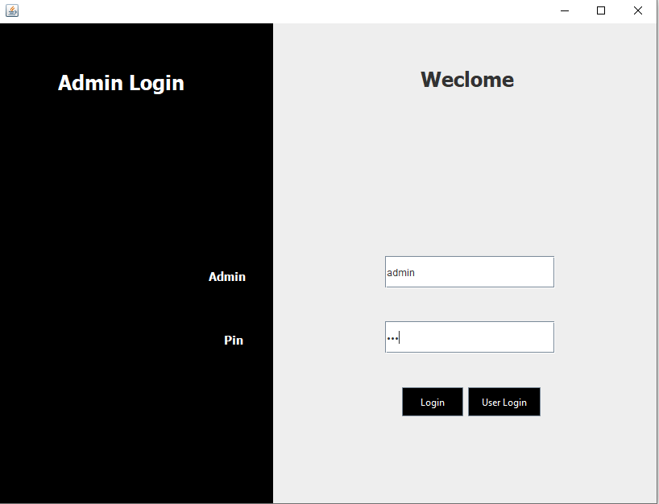 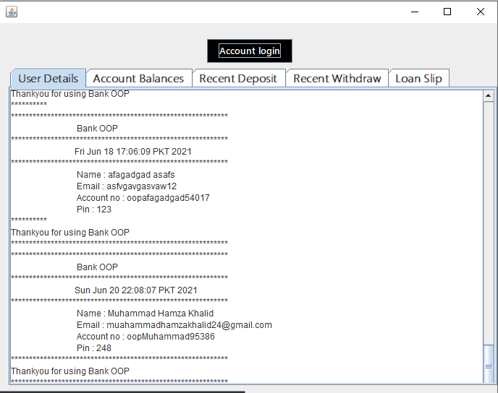

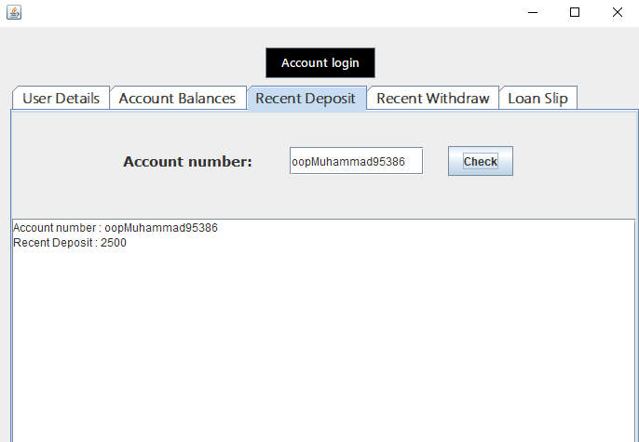

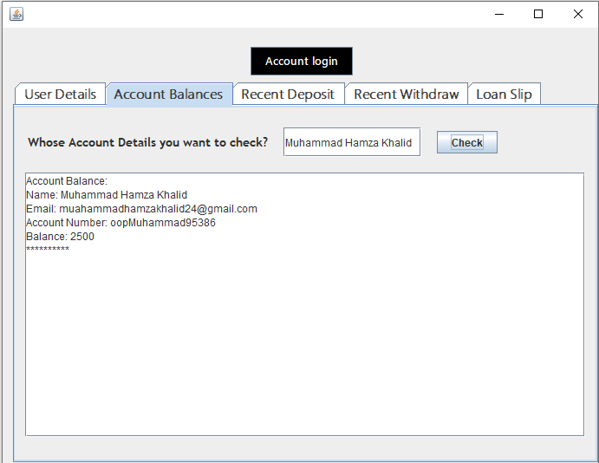

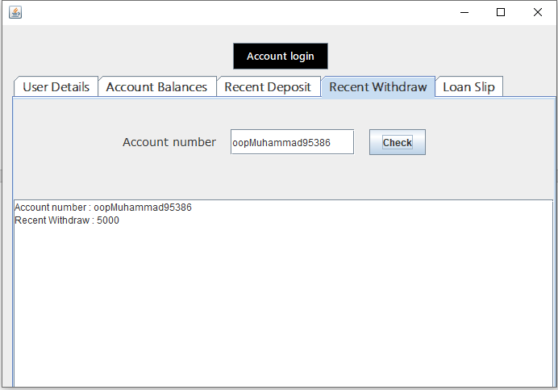

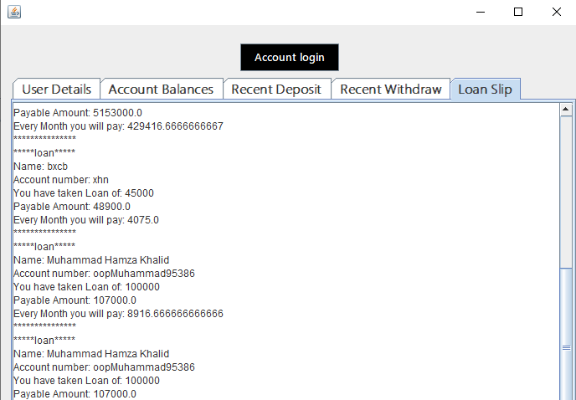7. Gantt Chart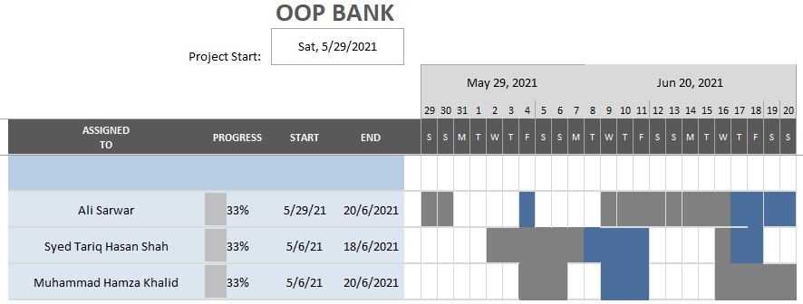

**\*\*\*FIN\*\*\***